
PRADHAN MANTRI FASAL BIMA YOJANA
(A Scheme for farmers by Government of India implemented by Bajaj Allianz General Insurance Company through the Government of Manipur)

Notification for Kharif 2023 season

CROP COVERED BY THE SCHEME: | HYV (High Yielding Variety) Paddy and Cabbage (Summer)
FARMERS COVERED BY THE SCHEME | All farmers including Sharecroppers/Tenant Farmers  - Loanee Farmers: Compulsory Insurance  - Non-Loanee Farmers: Voluntary Insurance  Non-Loanee farmers can insure their crops maximum up to 2 Hectare only
AREA COVERED BY THE SCHEME: | Block Level covering the entire state for both the crop
RISK COVERED:  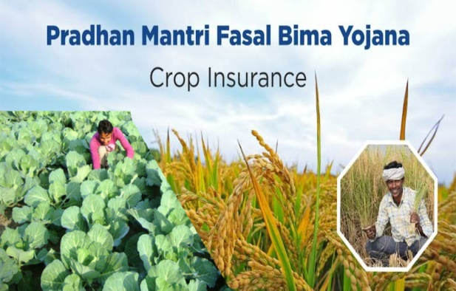 | - Preventing Sowing/Planting Risk: Deficit in rainfall or adverse seasonal conditions because of which the insure area is prevented form sowing/planting the insured crop.  - Risk with Standing Crop (Showing/Harvesting): Comprehensive risk insurance against non-preventable risk viz. Drought, Dry spells, Flood, Inundation. Pests and Disease, Landslides, Natural fire and lightning, Strom, Hailstorm, Cyclone, Typhon, Tempest, Hurricane and Tornado.  - Post-Harvest Loses: Coverage against cyclone and cyclonic rains and unseasonal rains for a maximum period of two weeks from harvesting.  - Localized calamities: Identified localized risk of hailstorm, landslides and inundation.  General Exclusion: War and Nuclear risks, malicious damage and other preventable risk shall be excluded.
SUM INSURED: | - Rs. 68,000/- per Ha. for HYV Paddy (both loanee and non-loanee farmers)  - Rs. 91,228/- per Ha. for Cabbage Summer (both loanee and non- loanee farmers)
FARMER’S PREMIUM RATE AND AMOUNT: | - 2 % of the Sum Insure (Rs. 1360 per Ha.) for HYV Paddy.  - 4 % for Tamenglong District (Rs. 3649 per Ha.) and 3 % for the remaining District. (Rs. 2737 per Ha.) Cabbage Summer.
LAST DATE FOR AVAILING INSURANCE/CUT OFF DATE FOR SUBMISSION OF PROPASALS: | 31st JULY 2023 (both HYV Paddy and Cabbage Summer)
HOW TO APPLY INSURANCE:
- LOANEE FARMERS: Insurance will be compulsory for the notified area of HYV Paddy. The premium will be deducted by the respective bank branches from the loan amount.
- NON-LOANEE FARMERS: Insurance may be availed by consulting with nearby bank branches or office of Bajaj Allianz General Insurance Company.
- DOCUMENTS REQUIRED FOR INSURANCE:
- Properly filled proposal form.
- Copy of Aadhar card.
- Copy of Bank pass book.
- Land documents and latest receipts of land tax payment.
- Certificate of sowing HYV Paddy provided by Agriculture office.
or
Certificate of sowing Cabbage (summer) provided by Horticulture office.
For more information please contact:
Government of Manipur
Nearest CSC/ Concern Bank/ District Agriculture Officer/ District Horticulture Officer or Directorate of Agriculture/Directorate of Horticulture, Sanjenthong, Imphal.
Mobile No.:- 8974026925/9774911944 Toll free No.: 1800 345 3822
Website: www.agrimanipur.gov.in

